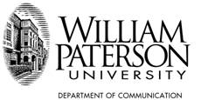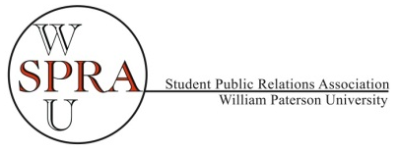

Fourth Annual PR Internship and Career Fair
Hosted by the Student Public Relations Association

Thursday, October 29, 2015
5:00 – 7:00 p.m. University Commons Ballroom A


http://cpronline.com/

 http://krausgroupmarketing.com/
Joel Kraus

 http://www.firstandlastpr.com/


http://spigroup.com/


http://www.rosica.com/

http://www.quinn.pr/


http://tbsmo.com/


http://www.thedsmgroup.com/


http://thes3agency.com/home


http://greenroompr.com/

http://smithsolve.com/

Also recruiting on campus interns for spring: University Galleries, Career Center, Marketing & Public Relations and more!

Dress professionally and be sure to bring multiple copies of your great resume! The event is open to students from all majors. Refreshments served. Event funded by S.G.A.

